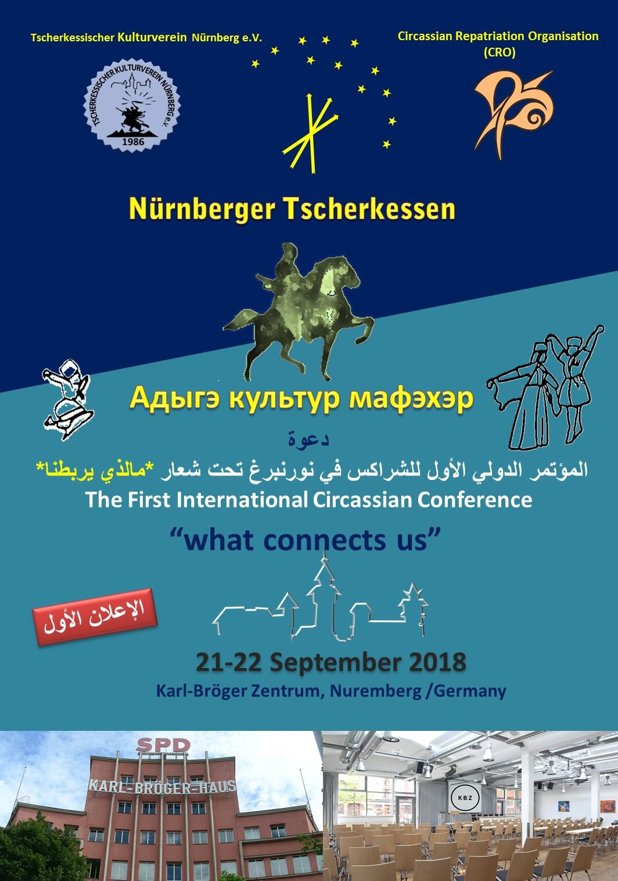

The First International Circassian Conference

y

21- 22. Sept. 2018
Karl-Bröger-Zentrum in Nürnberg
Karl-Bröger-Straße 9, 90459 Nürnberg German

Registration & Abstracts Form

Deadline for the Speakers is the 15th of August 2018
Hereby I confirm my participation in the First International Circassian Conference in Nuremberg
Last Name…………………………………..First Name………………………………….. Position: ………………Affiliation: ………………
Street………………………………….Zip code…………City ……………………………Country …………………… Tel.: ……………………………. Email……………………………
The Title should be indicated in English
Type Abstract Hier:

Please send your Abstracts in Word format by e-mail with :
    - Name of author(s) and the presenter in English language. With short CV, Personal Photo and contact address telephone numbers and email addresses.
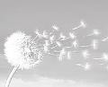
    - We will inform you about the Confernce Fee in the second announcement
    - lecture No O Yes O
    - Accommodation
Pickup from Hotel No O Yes O Hotel name Location, Date Signature

All Abstracts and short CVs should be sent to
Dr. med. Faidi Omar Mahmoud, Email: faidi.mahmoud@gmail.com and
Dr. Orfan Stash / Canada, E Mail orfan@uwaterloo.ca

